Augmented Reality Food Menu Application

Version 2.0

Revision History

|  |  |  |  |
| --- | --- | --- | --- |
| **Date** | **Version** | **Description** | **Author** |
| 27/10/17 | 1.0 | Add detailed information in Introduction, Project Overview, Project Organiztion and Project Monitoring and Control | Phu-Khoa Nguyen, Xuan-Vinh Nguyen |
| 01/11/17 | 2.0 | Edit Management Process | Phu-Khoa Nguyen, Xuan-Vinh Nguyen |
|  |  |  |  |
|  |  |  |  |

Table of Contents

1. Introduction 4

2. Project Overview 4

2.1 Project Purpose, Scope, and Objectives 4

2.2 Assumptions and Constraints 4

2.3 Project Deliverables 4

3. Project Organization 4

3.1 Organizational Structure 4

3.2 Roles and Responsibilities 4

4. Management Process 5

4.1 Project Estimates 5

4.2 Project Plan 5

4.2.1 Phase and Iteration Plan 5

4.2.2 Releases 5

4.2.3 Project Schedule 5

4.3 Project Monitoring and Control 5

4.3.1 Reporting 5

4.3.2 Risk Management 5

4.3.3 Configuration Management 6

# 

# Introduction

The Software Development Plan is a document that gives information about the Overview, Organization and Management Process of the project that REKT team will stick to and follow throughout the project

# Project Overview

## Project Purpose, Scope, and Objectives

The food menus are an indispensable part of every restaurant, from high-end ones to street food stalls. Most customers depend on the menus to make their dish choices. Nonetheless, there exists some limitations with the ordinary menus which only contain plain text and 2D images. For example, there are times that people order food and receive dishes that are not like they imagined.

Therefore, with that motivation, the authors' idea is to develop an application that brings Augmented Reality (AR) to food menus. Such application enables customers to see realistic virtual 3D models of dishes with detailed information about the ingredients included and how the plate is presented. In addition, there are also visualized ratings and reviews for each dish that customers can take into account when making decision. Moreover, the application of AR can lend some visual interest to food menus which can result in more customers attracted to the restaurants.

## Assumptions and Constraints

* Project has a fixed schedule of 9 weeks
* Zero-budget project
* Project has 4 members, there will be no more people added during the project
* Android-native application

## Project Deliverables

* An application that has 6 main features: 07/12/2017

1. Visualize foods in interactive 3D objects.

2. Order food

3. Login Facebook

4. Provide ratings, reviews, and visualize ingredients involved in a particular food

5. Checkout/Modify order

6. Customize food

* A demo with full features: 06/12/2017
* Database of reviews and ratings: 06/12/2017
* Project Plan: 03/11/2017
* Vision Document: 03/11/2017

# Project Organization

## Organizational Structure

## Roles and Responsibilities

|  |  |
| --- | --- |
| **Person** | **Role** |
| Khac-Tuan Nguyen - Team Leader, Developer, Tester  Bao-An Nguyen Tang, Designer, Developer  Xuan-Vinh Nguyen, Developer  Phu-Khoa Nguyen, Developer | Write reports, monitor project, coordinate meetings. Implement and test the application  Design components, classes, structures of the application. Implement the application  Implement the application  Implement the application |

# Management Process

## Project Estimates

Our team has estimated the project to be approximately 1000 lines of code involving with about 20 functions, costing at most 15 dollars for online training course (optional). The project is scheduled to last 9 weeks for a team of 4 members to complete. Those estimates are made under the circumstance that our team have no prior experience in both project field i.e. applying 3D model and project management. Therefore, Re-estimation is likely to usually occur along way with our working process.

## Project Plan

### Phase and Iteration Plan

*1. Inception: 9/10/2017 – 22/10/2017*

*The overall purpose of this phase is to define the scope, the risks and the benefits of the project.*

*Week 1:*

*Brainstorm ideas*

*Propose Project*

*Week 2:*

*Project plan, weekly report, vision document*

*Initial UI design*

*2. Elaboration: 23/10/2017 – 5/11/2017*

*Week 3,4:*

*Revised project plan*

*Revised vision document*

*Use case model*

*Complete design document: UI prototype*

*Test plan*

*Weekly reports*

*3. Construction: 6/11/2017 – 10/12*

*Week 5 – 8:*

*Implementation: Source code*

*Module Testing: test case, test plan.*

*Compile: Final program*

*Test report*

*Weekly reports*

*Week 9:*

*Demo and presentation*

### Releases

The first release is a demo on December 6th with full main features in fully-developed UI. The final release is a working application on December 7th with errors and bugs fixed compared to the demo on December 6th.

### Project Schedule

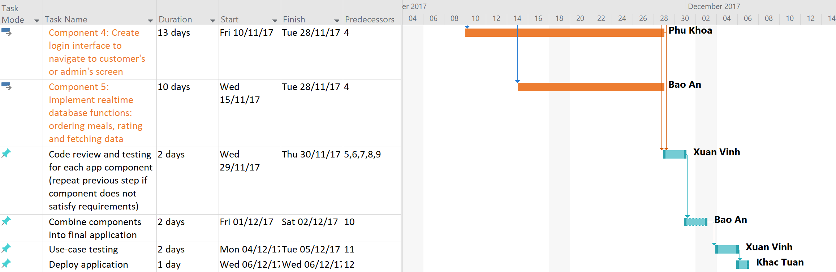

## Project Monitoring and Control

### Reporting

* Weekly meeting
* Informal chats

### Risk Management

|  |  |  |  |  |  |
| --- | --- | --- | --- | --- | --- |
| Risk ID | Risk Description | Probability | Impact | Priority | Mitigation Strategy or Contingency Plan |
| 1 | Fail to construct 3D model | Moderate | Catastrophic | high | Find some free simple 3D model online |
| 2 | Cannot using Vuforia SDK in Android Studio | Moderate | Serious | high | Use unity |
| 3 | Inco-operative team member | Low | tolerable | low | Others do his/her job |

### Configuration Management

* Google Drive for storing documents and source code
* Github for managing documents and source code
* Slack to communicate
* Trello for task assignments